What is Syntax?

SPSS *syntax* is a programming language that is unique to SPSS. It allows you to write commands that run SPSS procedures, rather than using the graphical user interface.

Syntax allows users to perform tasks that would be too tedious or difficult to do using the drop-down menus. This is the case when you are re-running the same analysis many times, or doing complex transformations on data. Syntax also provides a record of how you transformed and analyzed your data, and allows you to instantly reproduce those steps at any time.

Note that the two methods of interacting with SPSS—drop-down menus and syntax—are not mutually exclusive. You can use both methods if you wish (they will produce the same results), or switch from one method to the other depending on the actions you want to perform and your comfort level with menus or syntax*.*

## Basic Syntax Rules

### FORMATTING

* Statements in SPSS end with a period.
* SPSS syntax is not case-sensitive. You can use all lower case, all upper case, or a mixture of both when writing syntax.

### COMMENTS

A comment is a line of text in a program that is not read by the computer as a command. Comments do not affect how the program functions; they exist purely for the humans reading and writing the program. Comments help the reader understand what the program is doing. In general, it is good practice to use brief but descriptive comments in your code. Your comments should be clear enough that a reader completely unfamiliar with your work can understand what your program is doing.

In SPSS syntax, placing an asterisk (**\***) or a forward-slash followed by an asterisk (**/\***) at the start of a line will turn all text on that line into a comment. Hitting the Enter key will create a new, un-commented line. Typically, comments in SPSS syntax are color-coded with the color gray.

### COLOR-CODING

By default, SPSS uses color and bolding to indicate the roles of the words in the syntax.

|  |  |
| --- | --- |
| SPSS Syntax Color Coding | |
| **Dark blue/purple** | Procedure names; execution statements |
| **Green** | Statements associated with the given procedure |
| **Dark red/orange** | Option keywords |
| **Gray** | Comments |
| **Black** | Variable names; other text |

## Using Syntax

### OPENING THE SYNTAX EDITOR

To open a new Syntax Editor window, click **File > New > Syntax**.

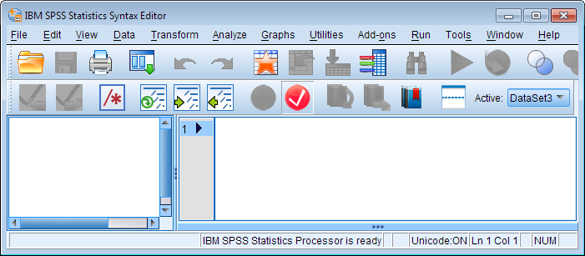

After you've opened a Syntax Editor window, you can start writing your syntax directly in this window. Alternatively, you can generate syntax while using the graphical user interface: almost all SPSS procedures accessed through the dropdown menus can generate syntax by clicking the **Paste** button instead of clicking OK/Run. After clicking the Paste button, the new syntax will automatically be added to your open Syntax Editor window.

### EXECUTING SYNTAX COMMANDS

To execute (or run) the commands, highlight the lines you want to run, then click **Run > Selection**, or press Ctrl + R on your keyboard.

### SAVING SYNTAX FILES

You can save your SPSS syntax as an *.sps file so that you can re-use it later. To save your syntax file, make sure that you have the Syntax Editor window open and active, then click **File > Save**or **File > Save As**to save the syntax file.

### OPENING SYNTAX FILES

To open a syntax file on your computer, click **File > Open > Syntax**. You can do this from any open window (including the Data View or Output View).

You can view the content of a syntax file (*.sps) using a text editor like Notepad or Notepad++, even on computers that do not have SPSS installed.

## Journal Files

By default, SPSS conveniently records the syntax for all of the commands run in SPSS (whether you used drop-down menus or syntax) in a Journal File (extension “.jnl”). This is convenient if you wish to review what commands you ran or if you want to edit or save the syntax commands for future use.

To find out where SPSS is storing this Journal File, click **Edit > Options**. Click **File Locations** and you will see the pathname for the Journal File in the Session Journal area. You can also change the location where this file is stored.

To open the Journal File, click **File > Open > Syntax**. Find the folder in which the Journal File is stored. In the **Files of type** list, select “All Files (*.*).” Now your Journal File should appear (e.g., statistics.jnl). Select this file and click **Open**. Now you can see the commands you ran during the most recent SPSS session. You can also save this file for future use. The file will save as a “.sps” file.

## Journal Files

By default, SPSS conveniently records the syntax for all of the commands run in SPSS (whether you used drop-down menus or syntax) in a Journal File (extension “.jnl”). This is convenient if you wish to review what commands you ran or if you want to edit or save the syntax commands for future use.

To find out where SPSS is storing this Journal File, click **Edit > Options**. Click **File Locations** and you will see the pathname for the Journal File in the Session Journal area. You can also change the location where this file is stored.

To open the Journal File, click **File > Open > Syntax**. Find the folder in which the Journal File is stored. In the **Files of type** list, select “All Files (*.*).” Now your Journal File should appear (e.g., statistics.jnl). Select this file and click **Open**. Now you can see the commands you ran during the most recent SPSS session. You can also save this file for future use. The file will save as a “.sps” file.

## Example: Comparing Drop-Down Menus versus Syntax

Here is an example of how to run the same command using both drop-down menus and syntax. Although we could choose any command, we will run a simple descriptives command on the variable *height*in our sample data set.

### GETTING DESCRIPTIVE STATISTICS USING THE DROP-DOWN MENUS

To run the Descriptives command using the drop-down menus, click **Analyze** > **Descriptive Statistics** > **Descriptives**.

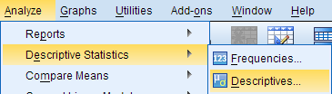

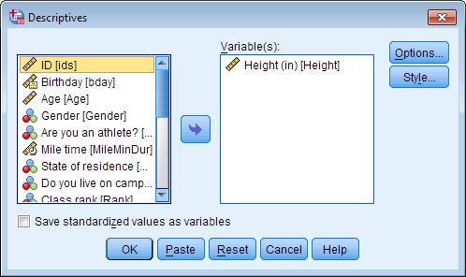

From the left menu, select the variable(s) you wish to run the descriptives command on, and use the arrow button to move them to the Variable(s) box. In this example, we select the variable*Height*. Click **OK**.

The results for the command will appear in the Output Viewer window.

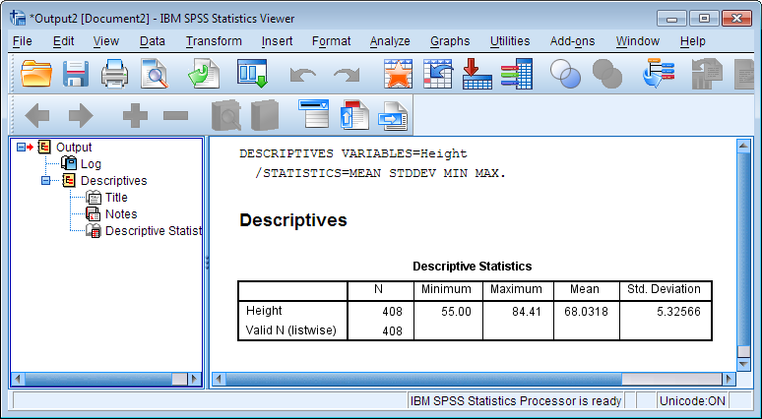

Notice that there is also syntax printed above the descriptive statistics in the output. The syntax provides a text-based map of the command we just ran using drop-down menus. If we had executed this syntax in a Syntax Editor window instead, we would get the exact same results as we did using the drop-down menu.

### GETTING DESCRIPTIVE STATISTICS USING SYNTAX

Let’s now use syntax to run the same Descriptives procedure as before.

Reopen the Descriptives procedure. All of your previous settings should still be active. Instead of clicking OK, click **Paste**. This should open a new Syntax Editor file with the descriptives syntax in it. (Alternatively, you can create a new syntax file by clicking **File > New > Syntax**, and typing or copy/pasting the following syntax into that window.)

Notice that that the text in the syntax editor appears in certain colors, and some words become bold. These stylistic formats simply define different parts of the syntax command.

**DESCRIPTIVES** VARIABLES= Height  
   /STATISTICS=MEAN STDDEV MIN MAX.

When you are finished typing the syntax, you need to tell SPSS to run the command by clicking the green arrow at the top of the window. Voila! We have produced the very same output using both drop-down menus and syntax.

**Note:**You can copy the syntax from an output window and paste it into a new Syntax Editor window to re-use, modify, and save the syntax. To copy syntax from the output (in the Output Viewer window), simply click the syntax, copy it, and paste it into a Syntax Editor window.

#### MODIFYING SYNTAX

Once you have syntax in the Syntax Editor window, you are free to modify the syntax and/or save it. For example, perhaps I decide that I want to look at some different variables, English and Writing, and I would like to get the range statistic instead of the minimum and maximum. I can easily modify the syntax I already have to accommodate these changes:

**DESCRIPTIVES** VARIABLES= English Writing  
   /STATISTICS=MEAN STDDEV RANGE.

Now when SPSS runs the descriptives command, it shows the range, mean, and standard deviation for the variables English and Writing.

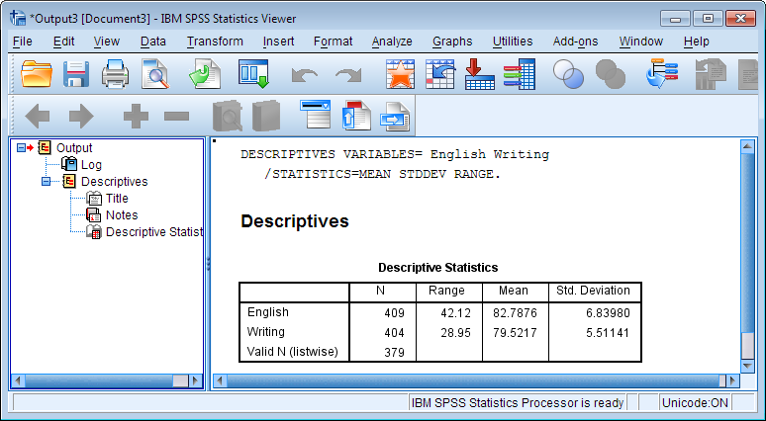

## When should I use syntax?

After the previous example, it may seem like the menus are easier to use than syntax. So why would anyone want to use syntax?

The biggest benefits of using SPSS syntax are **reproducibility** and **communication**.

### REPRODUCIBILITY

It is far easier to "retrace your steps" with syntax if you need to recall the modifications you've made to your dataset. It's also **far** easier to find and correct mistakes in your analysis if you have the syntax, as opposed to if you had used the menus.

Syntax can easily be modified and re-used on future projects, saving you time and effort in the long run.

If you are a Qualtrics user and have downloaded your "raw" survey data in SPSS format, using syntax to modify variable labels or compute new variables means that you don't have to worry if you lose the SPSS data file you've been working in; you can just re-download the raw data from Qualtrics and rerun your syntax to get your data back.